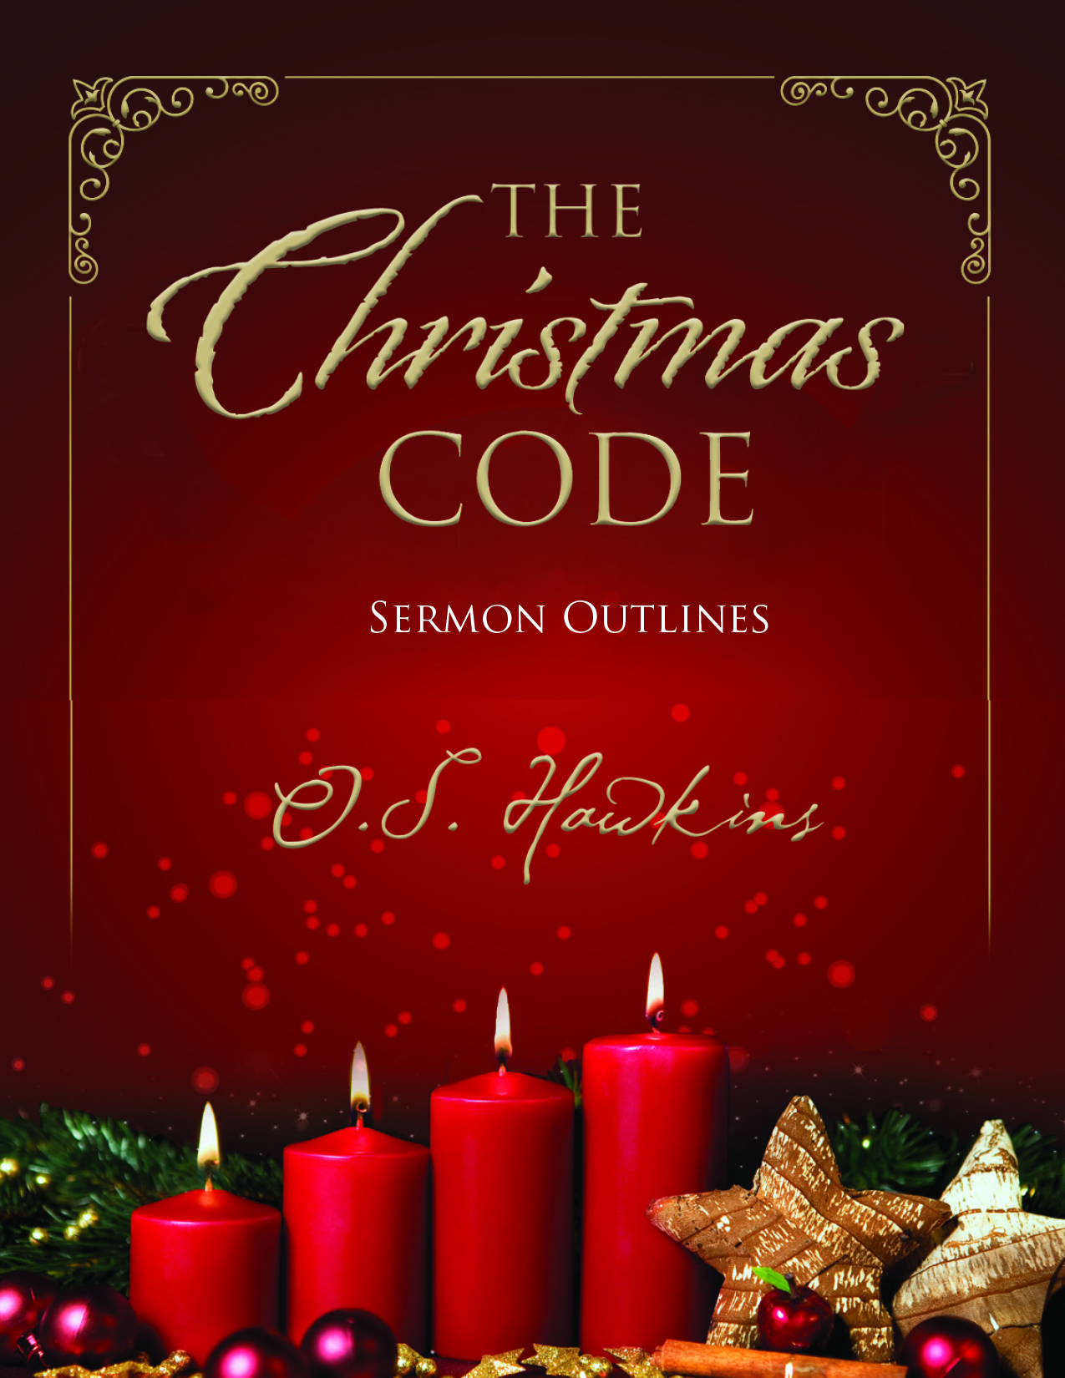MAKING THE MOST OF CHRISTMAS
Luke 2:15-20

For many people "making the most of Christmas" simply means some nostalgic, fuzzy feeling taken up with listening to carols in malls, decorating houses and trees and making sure of an invitation to that certain special Christmas party. But it can mean so much more.

Luke unfolds for us the account of a group of rather unlikely folks who have a lot to teach us about how to make the most of Christmas. When the shepherds heard the message of Christmas they didn't rush to celebrate it at the local bar in Bethlehem when they got off work. Nor did they gather for the annual Shepherd's company Christmas party or exchange gifts with one another. They made the most of Christmas. And, if we will follow their example, so can we. It involves four steps.

CALCULATE IT (Luke 2:15-16)

The night had begun like any other night. Then suddenly the heavens burst open with the angelic hosts bringing "good tidings of great joy"...a Savior had been born. The shepherds then said to one another, "Let us go now to Bethlehem and see this thing that has been made known to us." So they rushed up the mountain side to check it out for themselves.

How can we make the most of Christmas. Check it out. Put it in the calculator. Add it all up. Begin your search like they did. Open your Bible. Read Luke 2. Calculate it. Add it up. Check it out.

CONTEMPLATE IT (Luke 2:17-19)

The shepherds "marveled" at what they saw and heard. And Mary? "She kept all these things and pondered them in her heart." They contemplated, gave deep and prayerful thought to what it all meant.

Perhaps, for some of us, it has been a long time since we gave serious contemplation to all that the coming of Christ means and can mean personally. Use your private devotional time, to ponder for yourself, to be still and contemplate the true meaning of Christmas.

CELEBRATE IT (Luke 2:20)

Once the shepherds calculated what it all meant and contemplated on it they could not help but celebrate it. They "returned glorifying and praising God for all the things that they had heard and seen, as it was told them."

Why do you think December is filled with such anticipation and almost an atmospheric change in the air? People greet each other with smiles, even open doors for one another. Think about it. You walk through crowded malls and what do you hear on the sound systems? Songs of praise to the Christ, the carols of Christmas fill the air. And, God inhabits the praises of His people. May God give each of us the grace to truly celebrate Christ this season.

CIRCULATE IT (Luke 2:17)

The shepherds became witnesses of this very event. Their eyes had looked upon the One whom the prophets had foretold for centuries. They had heard the music of heaven. They calculated it, contemplated it, celebrated it...and now? They began to circulate this good news. "They made widely known the saying which was told them concerning this Child."

You may give your family and friends a lot of gifts this year, but the greatest gift you could every give would be to circulate to them the truth that Jesus came "to save His people from their sins."

The shepherds made the most of that first Christmas. And so can you this Christmas. Check it out. Marvel at its wonder. Give God glory by opening your heart to Him. And, don't keep quiet about it. Someone you know needs to know Christ. Share Him with others.

HAPPY BIRTHDAY JESUS
Luke 2:1-14

Over the years many of us have developed some strange ways of celebrating he birth of Christ. We decorate our homes inside and out. We watch football games. We travel half way across the country to be with family. We buy presents many of us can not really afford and spend much of the next year paying off the charges.

Jesus' birthday has evolved into one in which most of us come to His party bringing gifts to exchange with each other. Can you imagine inviting your friends to your birthday party and they ignore you and exchange gifts with one another?

You have an invitation this year to Christ's own birthday celebration. Don't leave Him in the manger. He left the cradle long ago for the cross and now wears a crown. This is the birthday of a King we celebrate this Christmas Day. And, there are some things we need to remember.

IT IS THE BIRTH OF A MESSIAH (Luke 2:11)

His was the most unusual birth ever recorded. He was virgin born. The angel announced there is born to you a "Savior who is Christ the Lord." First and foremost He is a SAVIOR. He came to "seek and to save those who are lost." (Luke 19:10). He is CHRIST, the anointed One, the Messiah. But that is not all. He is LORD. The King of all kings and the Lord of all Lords.

IT IS THE BIRTH OF A MESSAGE (Luke 2:10)

This "good news" derives from the Greek word for evangelism. The birth of Christ is the birth of a message that is to "all people." It is the good news that we can be forgiven, have a brand new beginning and be made clean. Yes, we shall call His name Jesus "for He shall save His people from their sins." (Matthew 1:22-23).

IT IS THE BIRTH OF A MISSION (Luke 2:14)

This mission is to bring "peace and goodwill to men." So much of our present talk of peace is superficial. Most of us think that peace is simply the absence of conflict. But it is not. The birth of Christ is the birth of a mission to bring true peace to the hearts of all men who will receive Him. We will never have peace with anyone else until first it begins in our own hearts by making peace with God through Jesus Christ our Lord.

IT IS THE BIRTH OF A MOVEMENT

Think about it. Here we two thousand years later and several thousand miles removed from Bethlehem. Yet, we are part of a world wide movement called the Church and the gates of Hell itself can never prevail against us. God always has a people no matter where you go in this world. Don't give up on the church. Christ has started a movement that will continue until He returns...not to Bethlehem as a Babe but to Jerusalem as a conquering King!

This is the birthday of King Jesus we celebrate this December 25. And the very best gift you can give Him is the gift of your life in total surrender to Him.

THOSE WHO MISSED THE PARTY
Matthew 2:1-8; Luke 2:7

We all love a party. While there were many who came to Christ's birthday party in Bethlehem, the shepherds and the wise men (although a bit belated), there were several who missed the party. Some didn't come because of their insecurity and were driven by their own self-centeredness. Others were simply indifferent, motivated by a sense of self righteousness. Still others were no shows due to ignorance, self-indulged with their own selfish desires.

SOME MISS THE PARTY WHO ARE INSECURE BECAUSE OF SELF CENTEREDNESS

Herod is our prime example here. He was "troubled" by it all (Matthew 2:4). And, why did Herod miss the party? He was only a few short miles away. He saw this baby being hailed as the "King of the Jews" as a threat to his own security and position. He was "troubled" when he heard the news because his self centeredness caused his insecurity.

Our own world is full of Herod's this Christmas. Oh, they might not be that vicious but, like Herod, in their own pride they see Christ as threat and don't want Him interfering with their own lifestyles.

SOME MISS THE PARTY WHO ARE INDIFFERENT BECAUSE OF SELF RIGHTEOUSNESS

The religious leaders are our example here (Matthew 2:4-6). They were not necessarily self centered. But, in their self righteousness they were indifferent to what was happening just a few miles away.

Things haven't changed much in two millennia. Much of the religious crowd today misses the true message of Christmas. Jesus is still crowded out by religious pride and preoccupation with the way we perceive spiritual things. Like the chief priests and scribes some of us are still missing the party in our own indifference.

SOME MISS THE PARTY WHO ARE IGNORANT BECAUSE OF SELF INDULGEMENT

The innkeeper stands on center stage here. Business was brisk in Bethlehem and no vacancy signs were hung at every inn. "No room" was his response to Joseph. In his thirst for self indulgement he was ignorant of the fact that the greatest event in human history was taking place in his own back yard.

Our world is filled with people like him today...preoccupied...consumed with their own self interests and priorities. And when these Bethlehem moments come their way they let them go being so convinced that something else they are doing is so important. And, like the innkeeper, in their ignorance, they let the moment go and never know what might have been.

While several missed the party, there were others, like the shepherds and the wise men, who joyfully journeyed to Bethlehem. God has sent you a special invitation. Make sure you are counted among those who attend this Bethlehem birthday.

LET US NOW GO TO BETHLEHEM
Luke 2:15

On that star filled night and down the hill from the little village of Bethlehem, was a group of common shepherds. While the big event of Christ's birth was transpiring unannounced just up the hill they had a surprise visit from heaven. After the angelic announcement of the Messiah's birth and hearing the praises of the heavenly choir, the shepherds said to one another, "Let us now go to Bethlehem and see this thing that has come to pass, which the Lord has made known to us" (Luke 2:15). So they came. And they found Him. Then they "returned glorifying and praising God for all the things they had heard and seen, as it was told them" (Luke 2:20).

Let's go to Bethlehem ourselves and ask, "Is my life a Bethlehem?" What do we mean? Bethlehem was a place of potential, a place of providence and a place of privilege. Our Lord desires that we of us become a Bethlehem.

BETHLEHEM IS A PLACE OF POTENTIAL

Think of it. Of all the places for this long awaited Messiah to be born, God chose Bethlehem. In Micah's words, it was "little among the thousands of Judah" (Micah 5:2). One would have expected Jesus to be born in Jerusalem or at least any of the scores of towns more prominent and positioned. But God has a way of dwelling among the lowly.

As the Lord looks into your life and mine today He does not see us for who we are but for who we could become. This is part of the message of Bethlehem. God can use any of us. We are people of potential.

God did not come to Caesar's palace to be born, nor Herod's court. But very quietly, almost incognito, He arrived in a seemingly insignificant little village, but a place of tremendous potential.

BETHLEHEM IS A PLACE OF PROVIDENCE

Long centuries before Christ's birth God foretold through the prophets that Bethlehem would be the birthplace of the promised Messiah of Israel. When reports spread of His birth Herod asked the chief priests where the birth was forecasted to take place. "In Bethlehem of Judea" was their immediate reply. But how could this be? Mary and Joseph resided in Nazareth seventy miles away. Luke records that a census was ordered and everyone had to return to the place of their lineage. God was putting the whole world in motion to fulfill His word.

God is still at work today...behind the scenes. "The Most High still rules over the kingdoms of men" (Daniel 4:17). He is still at work in world events and still holds "the King's heart in His hand" (Proverbs 21:1). Many things in our lives which appear on the surface as inconvenient as a seventy mile journey with a pregnant wife on the back of a donkey are really the hand of God getting us to our own Bethlehem. Like Bethlehem you are a place of potential and providence.

BETHLEHEM IS A PLACE OF PRIVILEGE

What a privilege to be the hand picked city to cradle the Son of God. Why not Jerusalem, the center of religious power? Or Rome, the center of political power? Or Athens, the center of intellectual power. Because the hope of our world is not in religion or politics or philosophy. It is in a Savior. Bethlehem is a place of tremendous privilege.

Like Bethlehem you can awaken to a whole new world. The same Christ born in Bethlehem can be born again in you! Paul framed it like this, "My little children for whom I labor in birth again until Christ is formed IN YOU" (Galatians 4:19). If you think Bethlehem is privileged to be the birth place of our Lord, what a greater privilege for Him to be born in you.

Thinking of Bethlehem, Phillips Brooks long ago said, "The hopes and fears of all the years are met in thee tonight." Like Bethlehem, you are a place of potential...providence...and privilege.

